Cohort analysis

Cohort analysis is a type of behavioral analytics in which you group your users based on their shared traits to better track and understand their actions. Cohort analysis allows you to ask more specific, targeted questions and make informed product decisions that will reduce churn and drastically increase revenue.

Since cohort Analysis to be done against customer acquasition. We will need
- Count of the customer
- Date columns (Order Date)
for customer count follow below
- Drag and drop Customer ID to row
- Right click on cutoemr id then go to measures and select countDist
For Date columns
- Drag and drop order date to columns

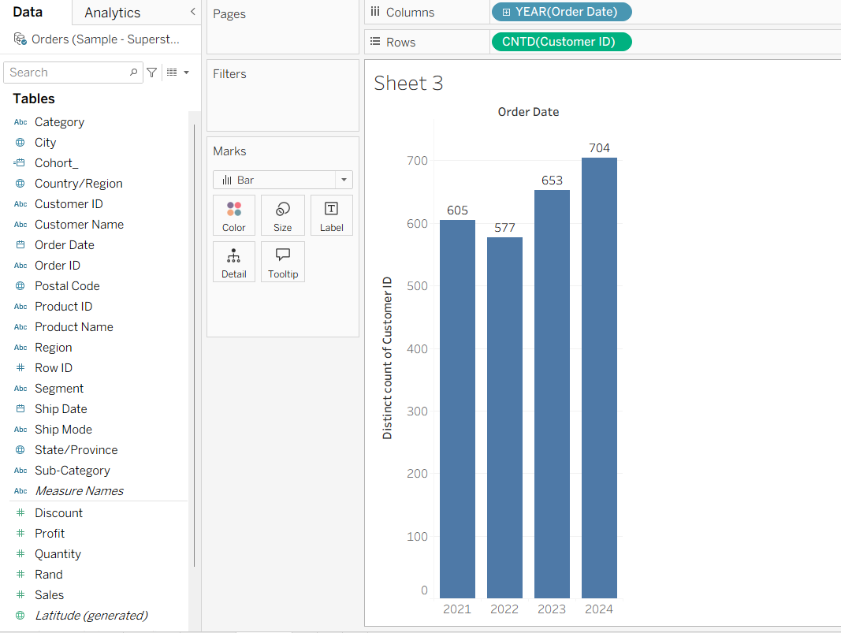

Now create cohort calculation
- Colu_Cohort { FIXED [Customer id]:MIN([Order Date])}
- Now drag and drop Colu_Cohort in colours(Marks)
